Special Variations Criteria – Resident Submission Instructions

Instructions
Go to City of Canada Bay Council | IPART (nsw.gov.au) - Here you can view the application for the minimum rate increase and the Joint Special Variation (SV).
To make a submission go to Special Variations & Minimum Rates 2023-24 | IPART (nsw.gov.au)
Click on the red box (circled below)
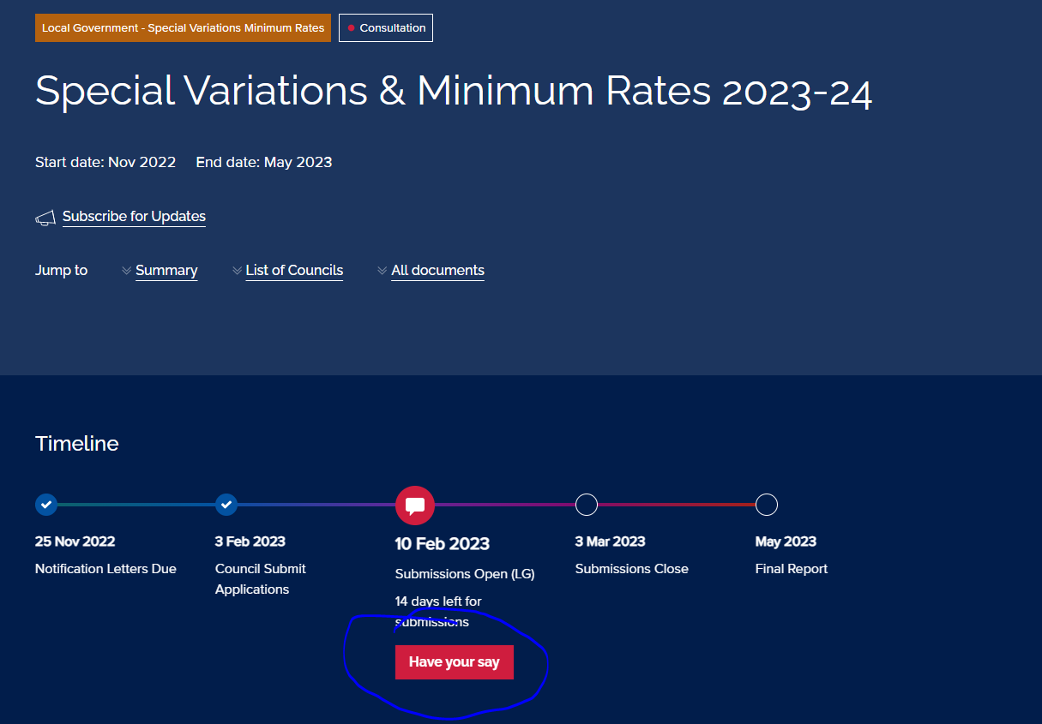

Choose City of Canada Bay Council, Joint Special Variation in the drop down box
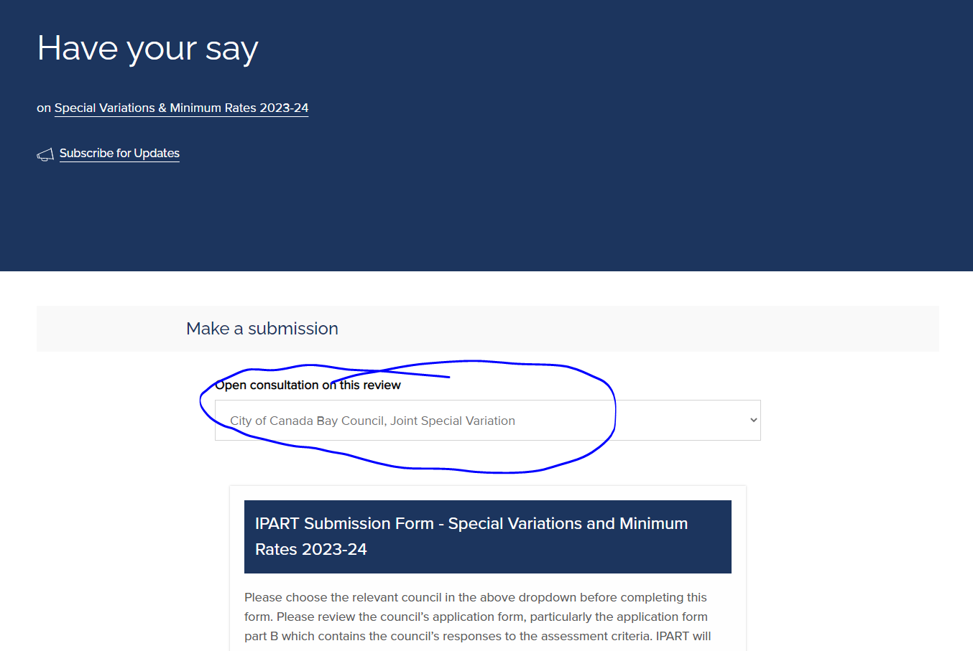
As you scroll down you will see a number of Criterion where input can be provided.
Below is the list of criterion and a response that you can copy and paste. Alternatively, you are able to write your own responses as you wish to.

IPART submission
Criterion 1
Question 1 (Criterion 1)
Has the Council established the need for, and purpose of a different revenue path for the council’s general fund?
No Comment
Question 2 (Criterion 1)
Has the Council canvassed alternatives to the rate rise?
No comment
Criterion 2
Question 1 (Criterion 2)
Did the council communicate the full cumulative increase of the proposed special variation in percentage terms? And the total increase in dollar terms for the average ratepayer by rating category?
No comment
Question 1 (Criterion 2)
Has the council's community engagement strategy demonstrated an appropriate variety of engagement methods to ensure community awareness?
No comment
Question 3 (Criterion 2)
Please comment on the action taken by council in response to feedback from the community on the proposed special variation.
No comment
Criterion 3
Question 1 (Criterion 3)
Please comment on the reasonableness of the impact on affected ratepayers of the proposed special variation.
Whilst the minimum rate increase and SRV is understood and is reasonable in principle, the Council has not considered a community like Breakfast Point that funds public infrastructure. The impact on these residents is significant with the minimum rate increase, SRV and most Community Association’s would also concurrently be increasing their levies to fund their infrastructure maintenance and renewals.
As a resident I do not believe that it is not reasonable to be funding public infrastructure twice and the Council’s approach is inequitable.
Breakfast Point residents fund 100% of the cost of the maintenance and renewal of all infrastructure on community property, majority of which is also 100% accessible to the public. This includes roads, footpaths, parklands, foreshore walkway, etc. It also pays the cost of running the open space and public street lighting in the suburb.
In addition, there is infrastructure also supplied to the community via the Breakfast Point Community Hall, meeting rooms, a Men’s Shed, BBQ area, oval, pool and tennis courts that takes pressure off the same infrastructure supplied by Council.
The public roads, footpaths, stormwater (including GPTS’s) and street trees are also the full responsibility of the Breakfast Point Community. Council charges each oner a user pays stormwater fee yet Breakfast Point owners are responsible for the maintenance and renewal of their own stormwater system.
Council only provides the user pays waste collection service and rangers to enforce the free parking in the suburb.
It is inequitable for the blanket approach of a rate increase without the consideration of what communities like Breakfast Point save the Council in cost and responsibility, and the significant cost that the residents of these communities are already paying to enable this.
Lastly, the Council has many opportunities to help offset the costs and realise savings through grant opportunities. Community Associations are often ineligible for the same grant opportunities. These communities and the way that they are structured save the Council a considerable amount of money.
Question 2 (Criterion 3)
Please comment on the council's consideration of the community's capacity and willingness to pay.
As a resident I understand and is not against the increase in rates and SRV, it is just disproportionate for the Breakfast Point residents as we are already funding the maintenance and renewal of public assets that are fully accessible to the public. In addition, we are funding community and recreational infrastructure that takes demand away from Council facilities.
The capacity to pay is diminished because of the recent increases in cost of living, particularly increases in interest rates.
Question 3 (Criterion 3)
In its application the council outlined how it intended to address hardship caused by the proposed special variation. Please comment on the council's plan.
No comment
Criterion 4
Question 1 (Criterion 4)
Have the relevant IP&R documents in the council's application been exhibited, approved and adopted by the council before it applied to IPART for the proposed special variation?
No comment
Criterion 5
Question 1 (Criterion 5)
In its application the council is required to explain and quantify the productivity improvements and cost containment strategies the council has realised in past years and plans to realise over the proposed special variation period. Please comment on the council's response here.
No comment
Other Comments and Attachments (Maximum of 2000 words)
I am very much against a double dip on rate charges that would clearly occur in our case should the proposed rate increase be implemented. As a resident that pays to help maintain the community assets and fund staff salaries, I also pay full council rates. In effect, with the proposed SRV increase, Council is asking residents of Breakfast Point to pay a considerable amount more for receiving less services than standalone owners.
I am not suggesting that Breakfast Point residents not pay a fair share of Council rates as we acknowledge we also use Council infrastructure. The inequity to all Breakfast Point residents will be significantly exacerbated with the magnitude of the proposed minimum rate increase and SRV. I respectfully, suggest the magnitude of the proposed increase are unjustified and should not proceed as proposed.

Next Step
After completing the submission, you chose that you are making an individual submission and then proceed to choose your preferred option for confidentiality etc. and finally then hit ‘Submit.’
